Name: ________________________________
Mood Meter Color: ____________________
Do Now

Key Points
1) Latitude and longitude are measured in degrees.
2) Latitude runs from East to West
3) Longitude runs from North to South

Guided Notes
- Latitude and longitude are measured in ___________________.
- Lines of ___________________ run from east to west.
- The equator is marked ___________.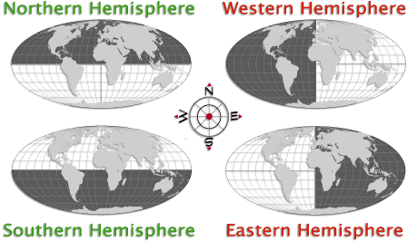
- Lines of Latitude above the equator are marked ______ for ________ because they are in the northern _________________.
- The ____________ __________________ is marked 0° and runs north to south.
- The prime meridian is a line of _______________________.
- Lines of Longitude that are to the west of the prime meridian are marked ____ because they are in the _____________ hemisphere.
- Lines of longitude that are to the east of the prime meridian are marked _____ because they are in the ______________ hemisphere.

List the approximate coordinates for the following cities using the map below:
- Buenos Aires _____,_________
- Tokyo ________,_________
- Capetown _____,_________
- Sydney ________,____________
- Moscow ________,____________

Name: ______________________
Mood Meter Color: __________
W
W
W
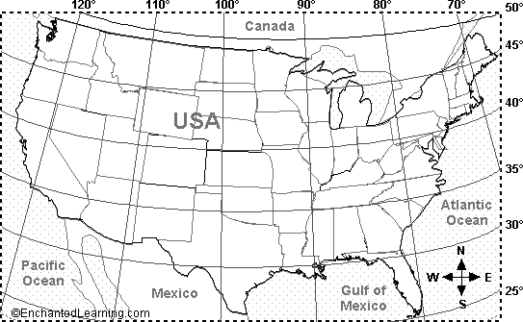
N
N
N
N
N
N
W
W
W
1. Which line of longitude on the map below passes through Texas?
- 90°W
- 100°W
- 30°N
- 35°N

2. Which of the following locations is in Mexico?
- 40°N, 120°W
- 50°N, 100°W
- 30°N, 110°W
- 35°N, 80°W

3. What is the approximate location of New Orleans?
  - 40°N, 120°W
  - 50°N, 100°W
  - 30°N, 90°W
  - 35°N, 80°W
4. What is the most approximate location of Los Angeles?
A. 45°N, 100°W
B. 35°N, 120°W
C. 25°, 100°W
D. 35°N, 110°W

