Name:________________________ Date:____________

Rise and History of Islam
07.06.03.04

Rise of Islam- Muhammad

- Muhammad was born in ________________ in Mecca
- He was born into a noble family
- He was visited by an angel, Gabriel, who said Muhammad was a ________________________________
- Muhammad question Gabriel, but eventually believed him and began spreading ______________

Mecca Battles
- Muhammad was pushed out of Mecca in _______________- this becomes known as the Hijra
- His migration from Mecca to Medina is the start of the Islamic calendar
- Between _________________the Muslims and the Quraysh tribe battle over Mecca
- Muhammad and the Muslims eventually win back _______________

Muhammad’s Death and After
- Muhammad died in ________________ without naming a successor- so the Muslims had to decide
- After his death, the Muslims began conquering more land
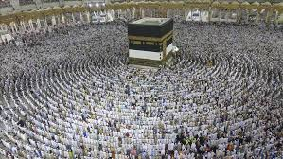

The Crusades

- The Crusades were a series of holy wars fought between European __________________ and _________________
- The Christians and Muslims fought over _____________________, otherwise known as the holy land
- The Crusades lasted from ________________ to _________________
