Name:______________________
Date:______________________

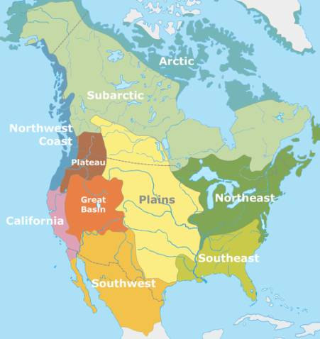
Native American Notes
Different Regions:
- Arctic/Subarctic
- Northwest Coast/Plateau
- California
- Great Basin
- Southwest
- Great Plains
- Southeast
- Northeast

Arctic/Subarctic

- _____________________________
- _____________________________
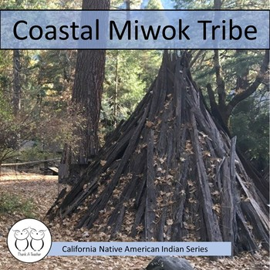
- _____________________________
Northwest Coast/Plateau
- ____________________________
- ____________________________
- ____________________________
California
- ____________________________
- ____________________________
Great Basin
- ____________________________
- ____________________________
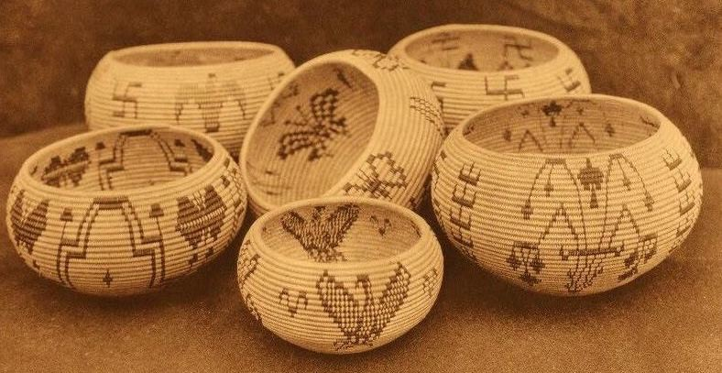
- ____________________________
Southwest
- ____________________________
- ____________________________
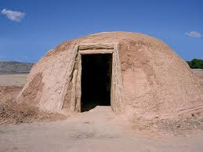
- ____________________________
Great Plains
- ____________________________
- ____________________________
- ____________________________
- ____________________________
- ____________________________
Southeast
- ____________________________
- ____________________________
- ____________________________
Northeast
- ____________________________
- ____________________________
- ____________________________

Tools
Various Native American groups used natural resources to create tools such as:
- ___________________________
- Wood from trees
- Rocks
Shelter
Native Americans used their natural resources to create their homes. Resources include:
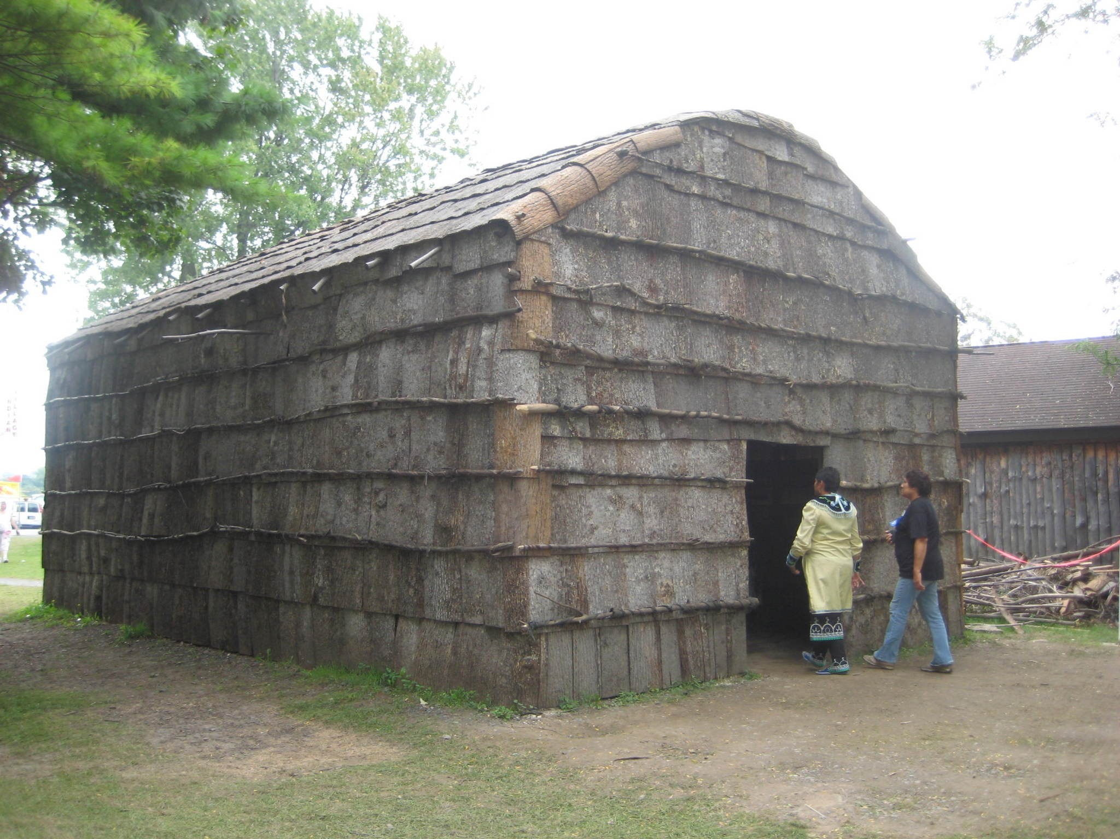
- _____________________________
- Dirt and mud
- Clay
- ______________________________
- Snow and ice
Clothing
Different Native American Groups used their natural resources to create their clothing. These resources included:
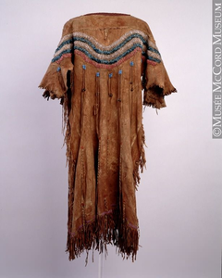
- Animal hides
  - ___________________________
  - Caribou
  - Seal
  - ___________________________
Artwork
Native American groups all created art in their own unique ways. Some art they created included:
- __________________________
- Masks
- Totem poles
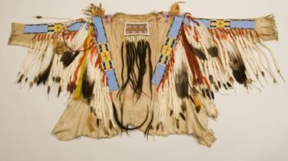
- __________________________
- Drawings
- Blankets
- Rugs
- __________________________
- Clay pots
Food
Different Native American groups relied on their location for food. Some of the ways they had food included:
- ___________________________
- ___________________________
- ___________________________
- ___________________________

