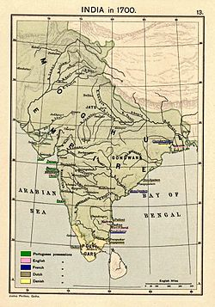
Name:_________________________
Date:_______________

Mughal Empire Notes

When and Where:
- The Mughal Empire lasted from ______________ AD to _____________AD
- The Mughal Empire was ___________________________in origin
- The empire ruled over most of Northern _______________

Babur
- Founded by ________________(ruled from 1526-1530)
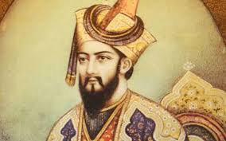
- Babur was related to __________________________
- Babur’s base was in _________________________________
- By the time he died in 1530, he ruled over all of ______________________________

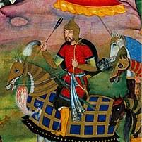
Humayun
- _____________________ son
- Ruled from ___________________________
- Lost control of empire to _______________________

Akbar
- Grandson of _____________________
- _______________________control of empire; ruled from 1556-1605
- Considered to be the __________________Mughal emperor
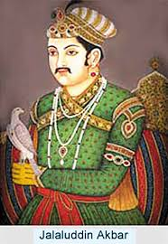

Fall of the Mughal Empire
- During Muhammad Shah’s rule (1719-1748), the empire began to _________________
- After his death, the next emperor ______________________ of the empire
- The last emperor was _______________by the British after his involvement with the Indian Mutiny of 1857-1858
- This brought _________________ of the Mughal Empire
