Name:_______________ Date:__________

Events Leading to the American Revolution Notes

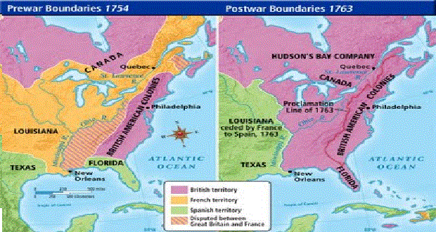
French and Indian War
- The two sides during this war were the ___________ versus the _____________
- Both sides had Native American allies (or help), but the French had ________
- Fought over the ________ River Valley (land)
- The __________ won, and forced the French out of the New World
Sugar Act
- 1764 Parliament (British government) passed the Sugar Act
- Reason: to pay off the ____________ from the French and Indian War
- Taxed the sugar and molasses brought into the colonies
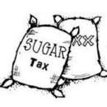
- Cost colonists lots of ___________
Stamp Act
- 1765 Parliament approved another tax
- This act put a tax on many _________ items in the colonies
- Newspapers, legal documents, playing cards, and more had a special tax
- Colonists were taxed without having a say- or without being ____________
Quartering Acts
- 1765 (1st act)/ 1774 (2nd act)- Colonists had to allow British soldiers into their homes
- Soldiers were able to stay at the homes- sleep and eat there
- Colonists COULD NOT turn the soldiers away!
Boycott
- Colonists wanted these taxes to go away, so they held ___________
- Boycott-to ___________using or buying a product
- This caused the Stamp Act to be repealed
- Repealed= ____________

Townshend Acts
- 1767 Parliament passed new tax laws called the Townshend Acts
- This taxed_________ , tea, paint, and paper that was brought into the colonies
- England even hired more tax collectors!
- The colonists were even more angry and ____________ more!

Boston Massacre
- These new tax collectors were like British soldiers all over the colonies
- The colonists didn’t like have these soldiers in their streets
- They got so angry that __________ would break out in the streets
- On_____________________, a large crowd of colonists gathered around the soldiers and threw rocks and snowballs at them.
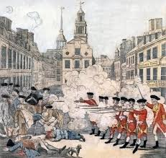
- The soldiers fired their guns
- ___________ colonists were killed on the spot and ________ others died later

Boston Tea Party
- 1773 Parliament passed the Tea Act
- This meant that colonist could only buy tea from England
- The ___________________decided to dress up as Mohawk Indians and sneak onto the boats
- Sons of Liberty-group of colonists who were mad about the new laws and wanted action!
- They dumped _____________of tea into the Boston Harbor

