Name:______________________ Date:__________________

Northern VS Southern Soldiers
Civil War:
- The Civil War took place from __________
- The North and the South could not agree on ________________________________________________
- The North wanted ________________________________
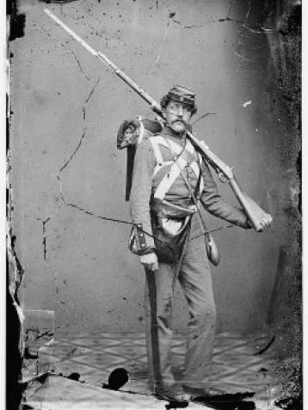
- The South wanted ________________________________
The North- The Union
- Soldiers were typically ___________________ years of age
- Many soldiers had been ___________________before the war
- Soldiers ranged in education- some went to college while others were ___________________ (couldn’t read or write)
- __________________fought for the Union- Germans, Irish, Canadians, and English
- Black men __________fight for the Union
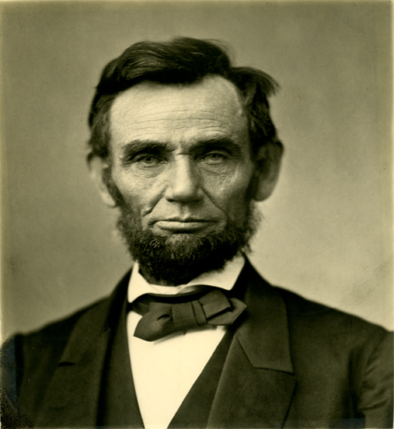
- Some ___________dressed up like men to fight in the army- like _________________________
- Soldiers in the Union Army __________ support slavery- they were fighting to end it
- The North was also fighting to __________________
- Union soldiers supported Abe Lincoln- the president is known as the “Great Emancipator”
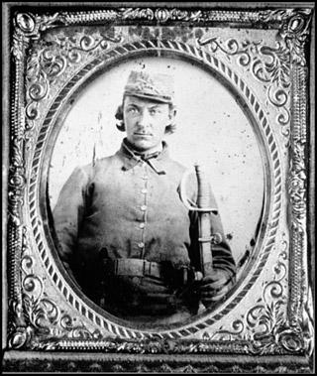
The South- The Confederacy
- Most Confederate soldiers were years of age
- Many of the soldiers had been ________________ before the war
- Many soldiers ranged in education- from college education to being illiterate
- Foreign men helped to fight for the Confederacy-_____________,_____________, French, Poles, and Canadians
- Some black men helped the Confederacy as ________________and__________________
- The South wanted to keep slavery- ____________________________________________
- They also argued that they were fighting for _____________________
- The South did not support Lincoln because he wanted to end slavery
- ______________________ was the President of the Confederate States
